**Martin’s packaging metrics**

Efferent Coupling (Ce)

“Calculates the number of Efferent Couplings for each package. An Efferent Coupling is a reference from a class or interface internal to the package to a class or interface external to the package. That is Afferent Couplings are Arriving references, Efferent Coupling are Exiting or Escaping references. References to test classes and library classes are not included.”

In summary, this metric is used to measure how many other modules a module depends on.

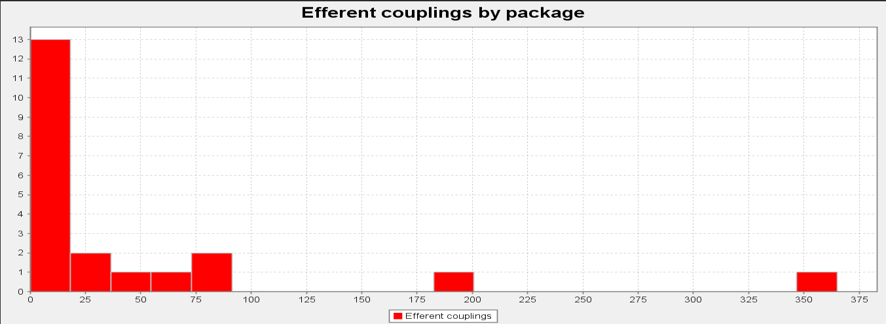

After running this metric trough, the Gantt Project, we conclude that many classes are not dependent on, but some are really relied on. This means that if any problem / changes / bugs are present in those, it could alter a lot on the whole program.

Afferent Coupling (Ca)

“Calculates the number of Afferent Couplings for each package. An Afferent Coupling is a reference from a class or interface external to the package to a class or interface internal to the package. That is Afferent Couplings are Arriving references, Efferent Coupling are Exiting or Escaping references. References from test classes and library classes are not included.”

In summary, this metric is used to measure how much a module depends on another module.

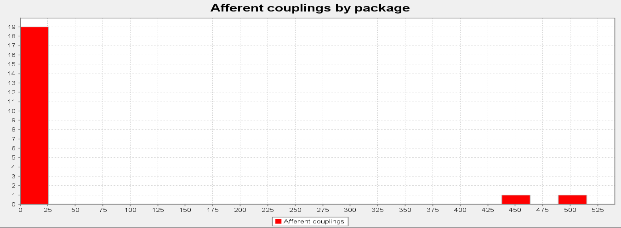

As we can see above, the data of this metric about the Gantt Project indicates that not many modules depend on another module, but some of them are dependent on various modules. With this latest part of the data, we can conclude that there are modules that can be easily compromised because they are dependent on so many other modules.

Instability (I)

“Calculates the Instability of a package. The Instability of a package is defined as the package's Efferent Couplings divided by the sum of the package's Afferent and Efferent Couplings (Ce÷(Ca+Ce)). This metric has a range of [0,1]. I=0 indicates a maximally stable package, I=1 indicates a maximally unstable package.”

In summary, this metric tells us is how stable a module is.

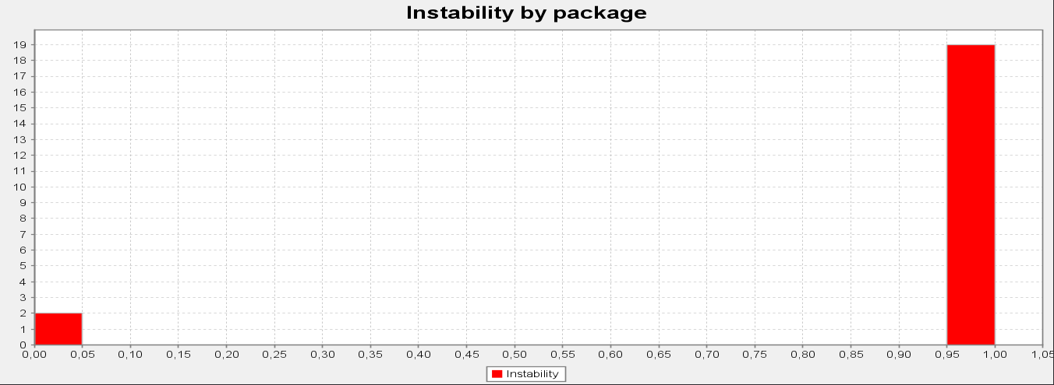

In conclusion with this last metric, the Gantt project is very stable as a whole, but some of its modules are very instable.